**WEEK-7**

**REACT**

**11. ReactJS-HOL**

**Create a React Application “eventexamplesapp” to handle various events of the form elements in HTML.**

**CODE:**

**Step 1: Setup the React App**

npx create-react-app eventexamplesapp

cd eventexamplesapp

npm start

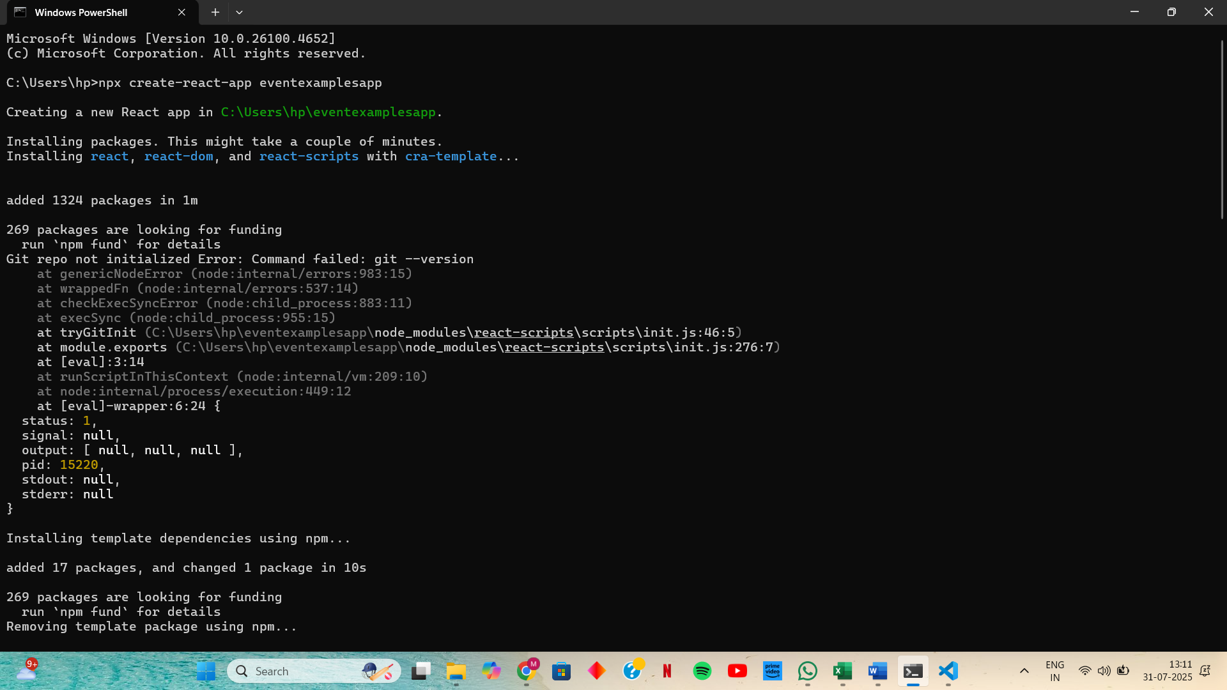

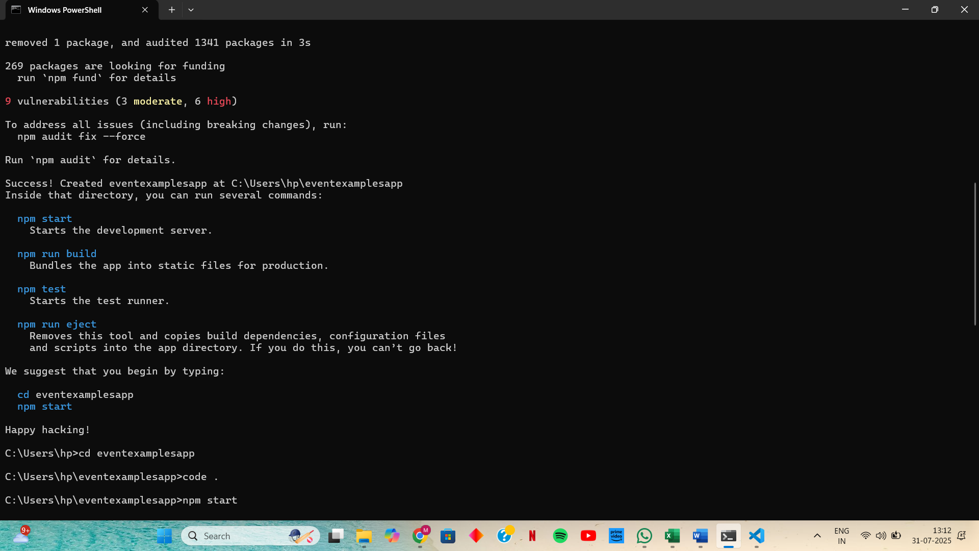

**Step 2: Create App.js inside src**

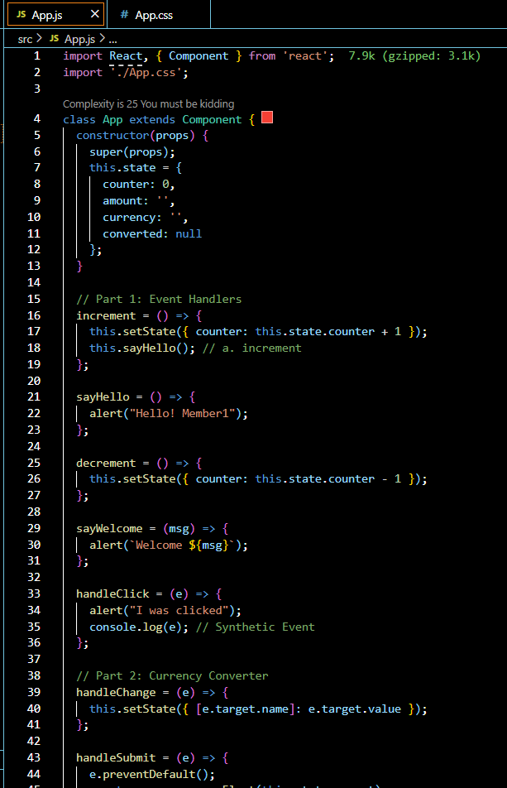

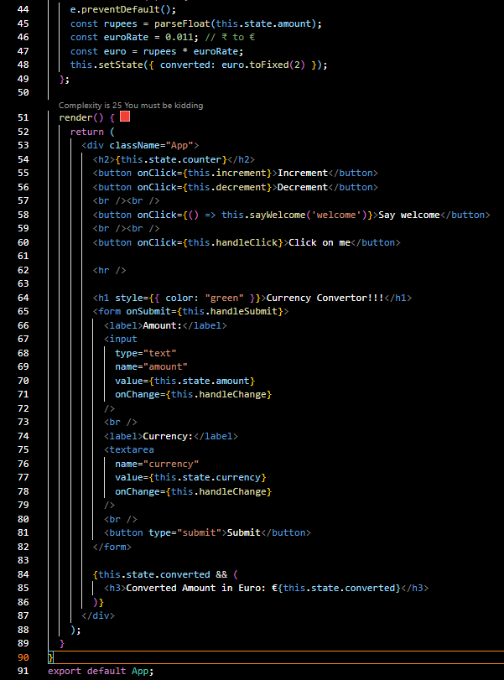

**OUTPUT:**

